UZBEKISTAN CHESS FEDERATION
Affiliate to FIDE.
Tel: (998712) 413501

Fax: (99871) 1351530
E-mail: uzchess@sarkor.uz

Asian Youth chess championship for boys and girls under 16
Namangan, Uzbekistan 28 May – 04 June 2005

Invitation.
UZBEKISTAN CHESS FEDERATION (UCF) has the pleasure of inviting your Chess Federation to participate in the Asian Youth Chess Championship for Boys and Girls Under 16 years old to be held in Namangan, Uzbekistan, from 28th May to 4th June 2005.

- Rules and Regulations.
The Championship will be played in accordance with the following rules and regulations proposed by UZBEKISTAN CHESS FEDERATION and approved by FIDE Continental President for Asia, Mr. Khalifa Mohammad Al-Hitmi.

- Eligibility and participation.
  - The players who are entitled to participate should not have reached the age of 16 by 1st January 2005 (Date of Birth-January 1st, 1989 and after).
  - Subject to age stipulation, the following are entitled to participate:
    - Each Federation from Zones 3.1(a), 3.1(b), 3.2, 3.3 and 3.4 shall be represented one player in boys and girls group.
    - The players placed 1-3 in the previous championship shall have the personal right to participate in the championship.
    - In addition, Each Federation shall be eligible to send extra players as special entree payment of US $ 150 per entry. Such players and each accompanies persons will be responsible for the payment of they board and loading expenses as well (US $ 40 per day for hospitality inclusive of 3 meals).

3.Accommodation.
The main participants (those who qualified by the normal way and by personal right) and accompanying official from each National Federation will be provided free board and loading from 28th May(dinner) to 4th June (lunch).
Those who arrive before the arrival date and or overstay beyond the departure date will also be charged according to the normal tariff.

4.Entry fee.
Each participating Federation shall pay entry fee directly to Asian Chess Federation for each participating main (75$) and extra(150$) player or to Uzbekistan Chess Federation before the first round.

5.Appeals Committee.
An Appeals Committee shall be constituted before the beginning of the tournament as stipulated in the FIDE regulations.
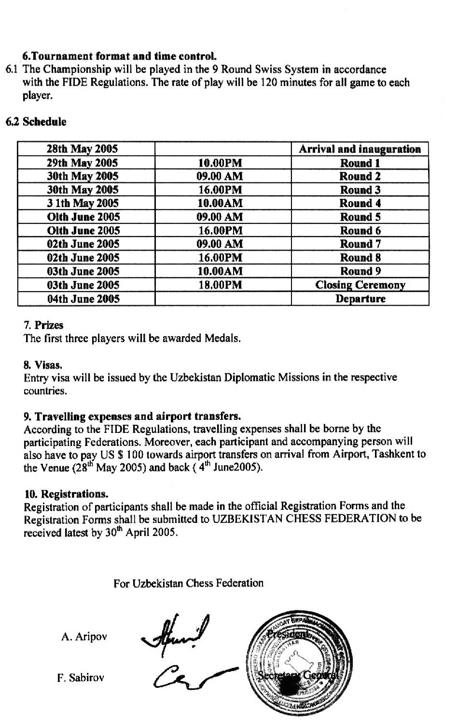
REGISTRATION FORM
Asian Youth Chess Championship for Boys and Girls Under 16 years old to be held in Namangan, Uzbekistan, from 28th May to 4th June 2005.

Please fax the completed registration forms latest by 30th April 2005 to:
F. Sabirov, Secretary General
Tel: (998712) 413501
Fax: (99871) 1351530
E-mail: uzchess@sarkor.uz

FEDERATION
ADDRESS
CONTACT PERSON |  | EMAIL
TEL |  | FAX

OFFICIAL PLAYERS
 | NAME | DATE OF BIRTH | FIDE RATING & FIDE ID № | PASSPORT № EXPIRY
PLAYER1
PLAYER2
OFFICIAL

ADDITIONAL PLAYERS
 | NAME | DATE OF BIRTH | FIDE RATING & FIDE ID № | PASSPORT № EXPIRY
PLAYER1
PLAYER2
OFFICIAL

ACCOMPANYING PERSONS |  | PASSPORT № | EXPIRY
NAME
NAME

FLIGHT DETAILS
DATE & TIME OF ARRIVAL
FLIGHT NUMBER

NAME & SIGNATURE OF RESPONDING OFFICIAL:

